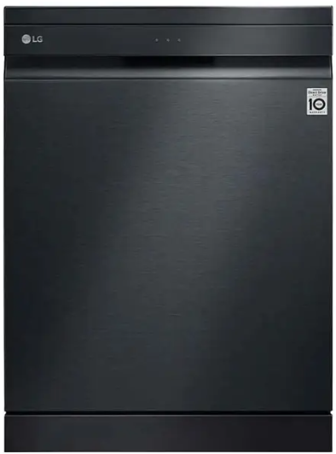

LG Freestanding Dishwasher
Rs.265,184
LG freestanding dishwasher DFB325HM uses True Steam, Quad Wash, Easy Rack Plus, and Inverter Direct Drive performance for efficient premium dish care.

Specifications
- Model: DFB325HM
- Type: Freestanding Dishwasher
- Drive: Inverter Direct Drive
- Smart Control: Thin

Key Features
- True Steam
- Quad Wash
- Easy Rack Plus
- Thin support

